1. 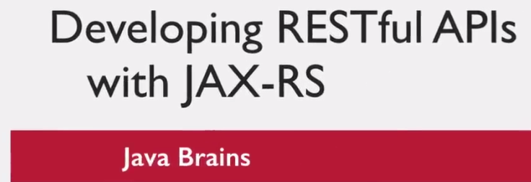
2. To learn how to write RESTful APIs or RESTful Web Services using JAX-RS, you need to learn two things
   1. RESTful APIs itself.
   2. How to implement RESTful APIs using JAX-RS.
3. 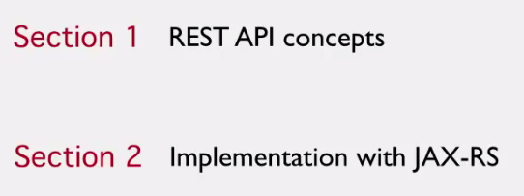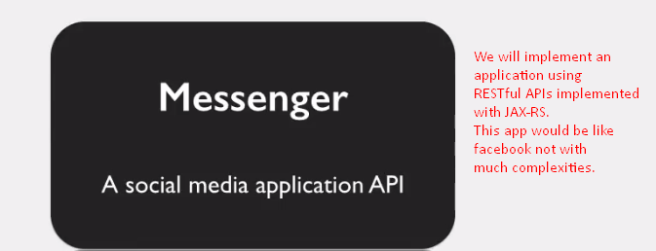
4. What is web service?
   1. Services exposed over internet for programmatic access (The online API that you can call from your code). 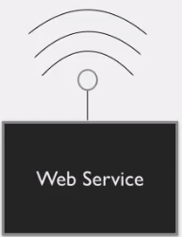
   2. 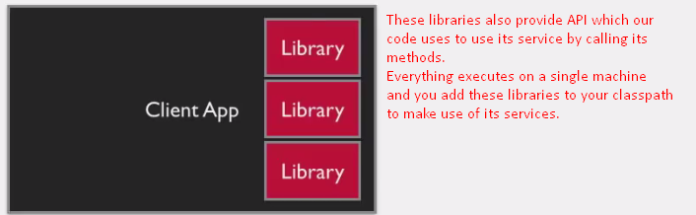
   3. 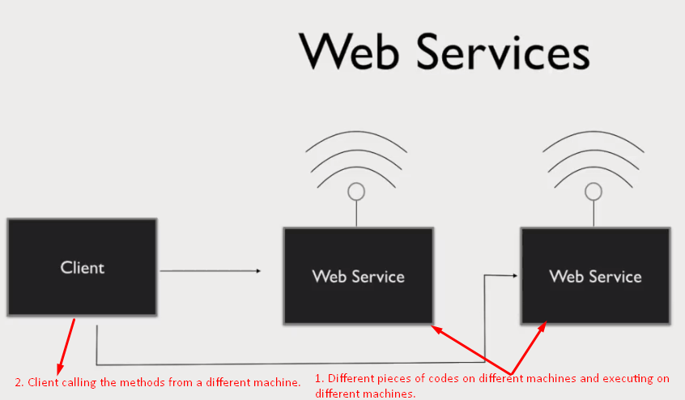
5. 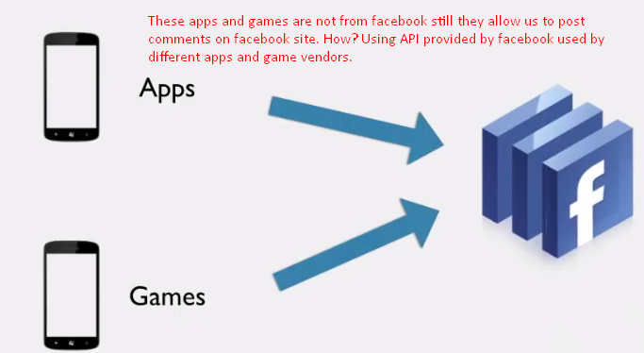
6. 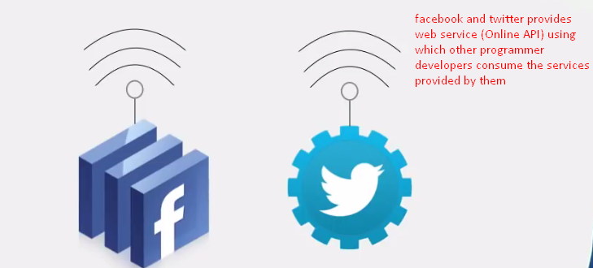
7. 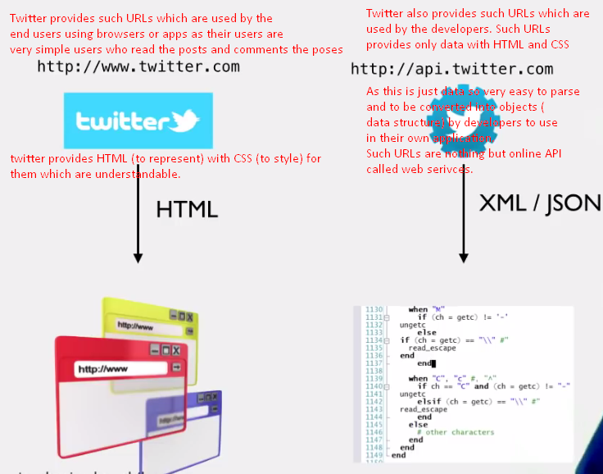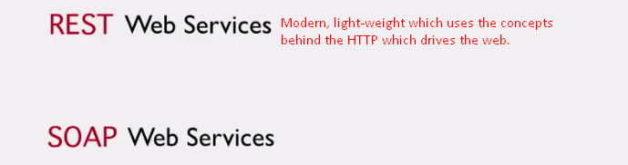

Characteristics of Web Services

1. Characteristics:
   1. **Web service over HTTP**: Where communication happens? Answer: Over web
   2. **Protocol**: As SOAP WS uses SOAP protocol. REST uses none to send message in a particular format.
   3. **HTTP Protocol and its methods**: In SOAP, we’ve to define the transfer protocol but in REST, no standard.
   4. **Service Definition**: WSDL as in SOAP, in REST, no Service Definition documentation.
2. First, the exchange of data happens over the web via HTTP.  
   🡸 1st, characteristic.
   1. 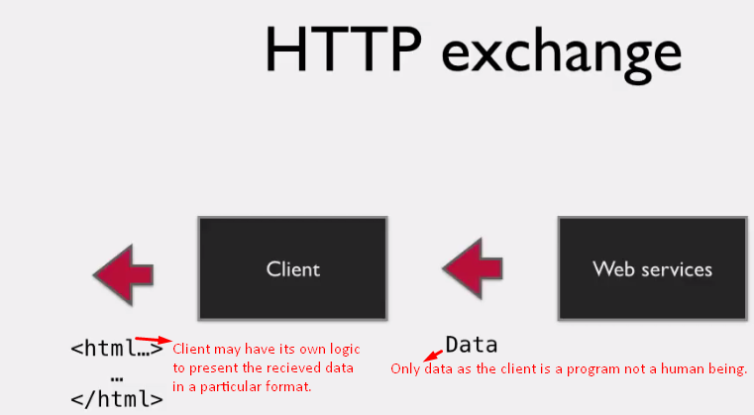
3. 
   1. Client sends message to server in the request and the server responds to client by sending response message. Now these messages must be in a particular format which client and server understand. Such contract b/w the client and server for the message format is nothing but protocol.
   2. SOAP (Simple Object Access Protocol): Some web service types such as SOAP WS uses SOAP to exchange messages which are in XML format. 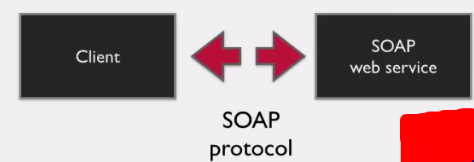
   3. What is the protocol in REST?
   4. None. Rest Client can send message in XML, JSON, TEST, Images as long as both of them (client, server) understand each other. They are happy. 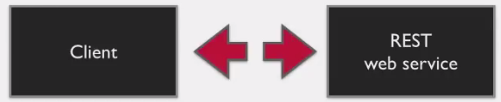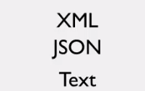
4. **Next characteristic**. How communication happens?
   1. We saw that RESTful web services are web services that means request and response happen over the web. But over http, there are different methods.   
      **Question**: Now which method to use to exchange data b/w the client and server. What is standard in case of RESTful Web Service?   
      **Answer**: None.  
      Data can be exchanged using any HTTP methods but there are some guidelines which tell us when designing our RESTful API (WS), what HTTP methods to use depending on the type of the operation.
5. **Another characteristic**: 
   1. **Service definition**: Means which methods, how parameters and type of each of them and the type of return type.
   2. In SOAP web service, there is WSDL file defining all the above.
   3. But in RESTful Web Service, there is no standard document you’ve to provide to your client to use your web RESTful Web Service.
   4. Actually how good the designed RESTful API is depends on how much documentation is needed by the client to use your RESTful Web Service.   
      The less the document, the more effective you RESTful API design.
   5. There is very little that your clients need to know which can be provided on the provider’s web page very easily.
6. SOAP has strict rules to each and every characteristic so far we have seen. The reason is that all the SOAP Web Services follow a specification called **SOAP Web Service Specification** which is a set of rules that dictate what every SOAP WS should be. These rules are defined by a committee. If any SOAP Web Service doesn’t follow any of the rules, the WS is not a valid WS.
7. Whereas, RESTful WS doesn’t follow any specification, it’s concept (an idea). There is no committee to tell you what is right and wrong.
8. The term REST was introduced by **Roy Fielding.**
9. 